PARISH: _________________________________________

The first question considers the October Count of the number of people attending your church for services and other acts of worship during the first 4 weeks of October. This includes the number of people attending on Sundays and during the week (Monday – Saturday). Please include any innovative and/or fresh expressions of church. (an activity or worship service created primarily for the benefit of those who are not yet or lapsed members of the congregation.)

You are asked to enter a count for each of the first 4 weeks of October. The count is split into Sundays and weekdays; adults and children; and type of gathering (worship, fresh expression and community based).

Number of services: The number of worship service or fresh expressions held on Sundays & weekdays. Enter ‘0’ if there were none.
Fresh Expressions: Gatherings focused primarily on those who are not yet members of the parish. Fresh expressions can be quite varied. (See last page for chart)
Community gatherings: These are services not held in your building(s) that are focused on the community.
Adults: 16 years old and over; please include those leading the gathering(s).
Children & Young People: Under 16 years old.

Please include:
- Clergy and other ministers attending and/or leading gatherings;
- Adults and children attending Sunday schools and/or similar activities;
- Attendance at baptisms (including any visitors);
- Any other church-based activities in which worship is the primary purpose;
- Attendance at services outside the building(s) – e.g., in homes, nursing/seniors’ homes, prisons and/or hospitals.

Please do not include:
- Attendance at weddings or funeral services;
- Activities with only some worship element (in home groups, parents & tot groups, youth groups, Alpha courses, social events – suppers, etc…)

1. How many people attended your church in October?
Week 1 | # of Services | Adult |  |  | Children & Young People
 |  | Church | Fresh Expressions | Community Based | Church | Fresh Expressions | Community Based
Sunday
Weekdays

Week 2 | # of Services | Adult |  |  | Children & Young People
 |  | Church | Fresh Expressions | Community Based | Church | Fresh Expressions | Community Based
Sunday
Weekdays

Week 3 | # of Services | Adult |  |  | Children & Young People
 |  | Church | Fresh Expressions | Community Based | Church | Fresh Expressions | Community Based
Sunday
Weekdays

Week 4 | # of Services | Adult |  |  | Children & Young People
 |  | Church | Fresh Expressions | Community Based | Church | Fresh Expressions | Community Based
Sunday
Weekdays

2. How often do you (and your ministry team) lead acts of worship in the community?
This question refers to acts of worship in building(s) that are not owned/occupied by your parish (or the diocese); e.g., a nursing home. Include any community gatherings of worship led by a person who holds a license for ministry (lay or ordained) within the diocese. Select the best option.
Never | Occasionally | Once or twice a year | Once a month | Bi-monthly | Weekly | More than once a weekly

The following questions are your worshipping community. Think about your regular community at the end of the previous year.
- Include anyone who attends your church regularly (at least once a month);
- Include all congregations in your parish (including fresh expressions);
- Do not include visitors (e.g., Christmas/Easter, baptism guests, etc…);
- Do not include people who consider their ‘home’ church to another parish or church;

3. How many people were in your worshipping community at the end of the previous year (average)?
Total | Children (0-10) | Young People (11-17) | Adults (18-69) | Adults (70+)

4. How has your worshipping community changed during the previous year?
- If you know how many people have left/joined your worshipping community but you do not know their reasons for leaving or joining, please enter the total figures (or your best estimate) only.
- If there is no one in a particular category, place a ‘0’.
- Do not count as joiners or leavers members of your worshipping community who move from ‘children and young people’ to ‘adult’.

How many adults and children JOINED your worshipping community during the previous year?
 | TOTAL | First Time | Moved into Area | Moved from a local church | Returned to church
Adults (18+)
Children & Youth People

How many adults and children LEFT your worshipping community during the previous year?
 | TOTAL | Death or Illness | Moved away | Moved to another church | Not worshipping anywhere | Other/Don’t know
Adults (18+)
Children & Youth People

5. What regular fresh expression(s) of church are supported by your parish?
There is space for three fresh expressions. If you have more, please continue on an additional sheet.Do not include Alpha courses or outreach activities that do not include worship.

[ ] None. (If your parish did not support any fresh expressions during the previous year, place an x here and leave the rest of this section blank.)

Name
Description of activity
Where is it held? (check all that apply) | [ ] Church [ ] Church Hall  [ ] Other (please note where): _________________________
How often? | [ ] Weekly [ ] Bi-Weekly [ ] Monthly  [ ] Quarterly [ ] Other: _______________
Target age group? (check all that apply) | [ ] All ages [ ] Family [ ] 0-4 [ ] 5-10  [ ] 11-17 [ ] 18-39 [ ] 40-69 [ ] 70+
Who attends? (check all that apply) | [ ] Attendees include people who regularly come to other services.  [ ] Attendees include people who occasionally come to other services.  [ ] Attendees include people who never come to other services.

Name
Description of activity
Where is it held? (check all that apply) | [ ] Church [ ] Church Hall  [ ] Other (please note where): _________________________
How often? | [ ] Weekly [ ] Bi-Weekly [ ] Monthly  [ ] Quarterly [ ] Other: _______________
Target age group? (check all that apply) | [ ] All ages [ ] Family [ ] 0-4 [ ] 5-10  [ ] 11-17 [ ] 18-39 [ ] 40-69 [ ] 70+
Who attends? (check all that apply) | [ ] Attendees include people who regularly come to other services.  [ ] Attendees include people who occasionally come to other services.  [ ] Attendees include people who never come to other services.

Name
Description of activity
Where is it held? (check all that apply) | [ ] Church [ ] Church Hall  [ ] Other (please note where): _________________________
How often? | [ ] Weekly [ ] Bi-Weekly [ ] Monthly  [ ] Quarterly [ ] Other: _______________
Target age group? (check all that apply) | [ ] All ages [ ] Family [ ] 0-4 [ ] 5-10  [ ] 11-17 [ ] 18-39 [ ] 40-69 [ ] 70+
Who attends? (check all that apply) | [ ] Attendees include people who regularly come to other services.  [ ] Attendees include people who occasionally come to other services.  [ ] Attendees include people who never come to other services.

6. How many baptisms of a child where held in your parish during the previous year?
 | Infants  (<1 year) | Children  (1-4) | Children  (5-12) | Youth  (13-18) | Adults  (19+)
Number of baptized individuals
Thanksgiving for A Birth

7. How many marriages and services of prayer and blessings after a civil marriage were held in your parish during the previous year?
Number of couples married in your parish.
Number of couples for whom a service of blessing was held (after a civil marriage).

8. How many funeral services were held at or on behalf of your parish during the previous year?
- Include all funerals that were held in your church;
- Include all funerals or burials officiated by any member of your ministry team (layreaders, clergy, deacons, evangelists, parish workers) at a funeral home or cemetery.
Number of deceased for whom a funeral service was held at your church.
Number of deceased for whom a full funeral service was officiated by a member of your ministry team at funeral home or cemetery.

Looking back across the previous year, were there any exceptional circumstances (e.g., an interim ministry or building projects) or significant changes that may have led to unusual figures in this return?

9. Finally, there is a special focus question about social action/community impact. A parish’s engagement with their communities and response to social issues can take many forms. This question asks about your parish’s involvement in those activities. Please only include organized activities that are primarily hosted for the benefit of the wider community (not primarily focused on members of the parish).
Please select all that apply to your parish – as many columns as apply for each activity. | Our parish is responsibility for running this activity. | Our parish hosts this activity in our own building(s). | Our parish does this activity in partnership with others (e.g., another church, charity, community group, etc..) | Our parish supports this activity in other ways (e.g., volunteering, donations – financial & supplies) | Frequency
Community Café
Food Bank
Vacation Bible Club
Breakfast Club
Afterschool Program
Lunch Program
Drop-in Program
Money Matters and/or Debt Advice
Emergency Shelter
Homeless Shelter
Parents Support
Play group
Addiction Services
Pastoral Services
(street pastors, counseling, etc..)
Youth work (community focused)
Other (please specify)

Other (please specify)

Other (please specify)

Other (please specify)

Is there any additional information we should be looking to capture within the Statistics for Mission?

Thank you for completing your annual return on behalf of your parish. Your contribution is essential to the on-going care and understanding of our parishes and congregations; your diligence, time, and effort are greatly appreciated. Please take a moment to review your answers. Make sure that you have completed every question as far as possible and not left any answers blank (use ‘0’ or N/A as necessary).

- Bishop and Synod

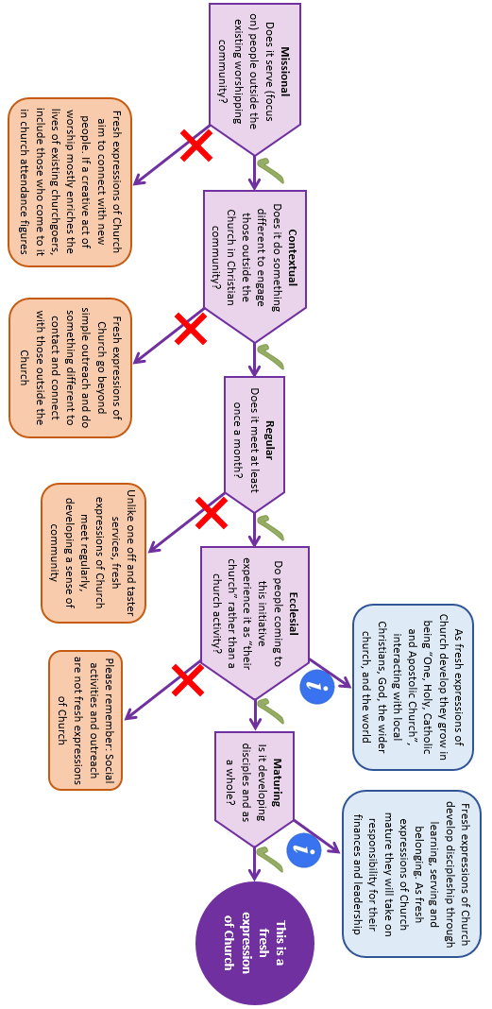
Figure 1 - Fresh Expressions determination chart

